|  |  |
| --- | --- |
|  | |
| DATAWAYS-COA-ALL-140-My Scope of Services  Functional Specification | |
| Department: CMA CGM Commercial and Operational Allocation  Project: *DATAWAYS*  JIRA ID: *ALL-140*  Author(s): Infosys | |
| Doc Reference:  Date:  Version:  Status: | DATAWAYS-COA-LT-FND-ALL-140-My Scope of Services  27-Feb-2024 1.4 Approved |
| Classification: **Internal** | |

REVISIONS

|  |  |  |  |
| --- | --- | --- | --- |
| **Version** | **Date** | **Author** | **Subject** |
| 0.1 | 21-Feb-2024 | Savli | Document creation |
| 1.0 | 27-Feb-2024 | Savli | Document approved |
| 1.1 | 04-Mar-2024 | Savli | * The user will not be allowed to override the quick default filters in Cargo Flow Portal. |
| 1.2 | 07-Mar-2024 | Savli | * Change of position of Error message display (BR10) * NFR BR added |
| 1.3 | 20-Mar-2024 | Savli | * Removed the reference data table of the bounds from (BR06) |
| 1.4 | 22-Mar-2024 | Savli | * Service ID will be fetched from the Schedule and not Master data. Changes done in Constraints and Assumptions section and in BR05 |

**REVIEWS**

|  |  |  |  |  |  |
| --- | --- | --- | --- | --- | --- |
| **Name** | **Title** | **Version** | **Date** | **Company** | **Signature** |
| Prabhu SESHADRI | IT Domain Lead | 0.1 | 27-Feb-2024 | CMA CGM | Prabhu SESHADRI |
| HIENG Laurent | Product Owner | 0.1 | 27-Feb-2024 | CMA CGM | HIENG Laurent |

APPROVALS

|  |  |  |  |  |  |
| --- | --- | --- | --- | --- | --- |
| **Name** | **Title** | **Version** | **Date** | **Company** | **Signature** |
| HOELLARD Damien | Lead Product Owner | 1.0 | 27-Feb-2024 | CMA CGM | HOELLARD Damien |

DISTRIBUTION LIST

|  |  |  |  |  |
| --- | --- | --- | --- | --- |
| **Name** | **Title** | **Company** | **To** | **Cc** |
| HOELLARD Damien | Lead Product Owner | CMA CGM | X |  |
| HIENG Laurent | Product Owner | CMA CGM | X |  |
| Prabhu SESHADRI | IT Domain Lead | CMA CGM |  | X |
| Veronique JOUSSELLIN | IT Domain Owner | CMA CGM |  | X |
| Julien D’ELIA | Enterprise Architect | CMA CGM |  | X |
| Youssef ATIK | Solution Architect | CMA CGM |  | X |
| Rudy MACARONUS | Chief Architect | CMA CGM |  | X |
| Victor BONY | Project Manager | CMA CGM |  | X |
| Ganesh IYER | Proxy Product Owner | Infosys |  | X |
| Ellina GALCHENKO | Product SME | Infosys |  | X |
| Irfan KHAN | Product SME | Infosys |  | X |
| Savli TAPRE | Product SME | Infosys |  | X |
| Aishwarya RAJAN | UX Lead | Infosys |  | X |
| Tameshwar SAHU | Solution Architect | Infosys |  | X |
| Tapas SARKAR | Solution Architect | Infosys |  | X |
| Bala Chami | Scrum Master | Infosys |  | X |
| Sinchu PANICKER | PMO | Infosys |  | X |

CONTENTS

1 - Requirements 4

1.1 Document references 4

1.2 New or Modified Objects 4

1.3 Acronyms & Glossary 4

2 - Detailed Design 6

2.1 Business Context and Scope 6

2.2 Business Constraints or Assumptions 6

2.3 Functional Solution Risk 6

2.4 Requirement Details 6

2.5 Process Flow and Domain Entities 7

2.6 UI / UX Design 7

2.7 Validation and Rules 18

2.8 Setups and configurations 19

2.9 Processing definition 19

2.10 Functional Test Cases 34

3 - Technical Details (Optional) 39

# - Requirements

|  |  |
| --- | --- |
| **Requirement ID** | **User Story/Requirement Description** |
| ALL-140 | My Scope of Services |

## 

### Document references

|  |  |  |  |  |
| --- | --- | --- | --- | --- |
| **Reference** | **Description** | **Version** | **Date** | **Author** |
|  |  |  |  |  |
|  |  |  |  |  |

### 

### New or Modified Objects

|  |  |
| --- | --- |
| **Components involved and purpose (Part of technical Document)** | |
| Screen ID xxx |  |
| API Name xxx |  |
|  |  |
|  |  |
|  |  |
|  |  |

### Acronyms & Glossary

|  |  |  |
| --- | --- | --- |
| **Term** | **Acronym** | **Definition** |
| Cargo Flow Bounds | Cargo Flow Bounds | A schedule bound is a segregation of a technical voyage into separate blocks that indicate the direction of the vessel sailing.  Schedule bounds have a 1:1 relation with a Commercial Voyage Number (CVN).  Schedule bound are displayed as E, W, N, S and RT. The same is shown as E = EB, WB, NB, SB in cargo flow bounds. |
| Commercial Group of Lines | Commercial GOL | Lines are grouped for commercial perspective |
| Line | Line | Regular service offered by shipping company with a predetermined route (consisting of a rotation) and sequence of ports |
| Service | Service | Service (Line) is a regular rotation operated by a group of vessels for a dedicated geographical corridor. |
| Service ID | Service ID | Service ID is a unique identifier associated with the Service. |
|  |  |  |

# - Detailed Design

### Business Context and Scope

This document covers the functionality of setting up my scope of services in the Home Page. These filters will be used as quick filters for Cargo Flow Portal by the Cargo Flow users. The purpose of these filters is to facilitate the user in accessing the data that is relevant to user’s business scope. My scope of services will have Commercial GOL, Service ID, Cargo Flow Bound, Add, Cancel and Save button.

### Business Constraints or Assumptions

* Commercial GOL should be present in the master data which can be used in the new application.
* Service ID data will be fetched from the schedule.
* Any Cargo Flow user can set my scope of services filters.

### Functional Solution Risk

N/A

### Requirement Details

As per the business requirement, a Cargo Flow user should be able to access and set my scope of services filters. It will be a screen defining the business scope of the Cargo Flow user, based on the following attributes

* Commercial GOL
* Service ID
* Cargo Flow bound

Once the user updates all the mandatory fields based on the above attributes and the validation checks are done, the user can save the ‘my scope of services’ and the scope will be set for all the sections in the user’s Cargo Flow Portal.

### Process Flow and Domain Entities

### UI / UX Design

* Home Page navigation to my scope of services screen

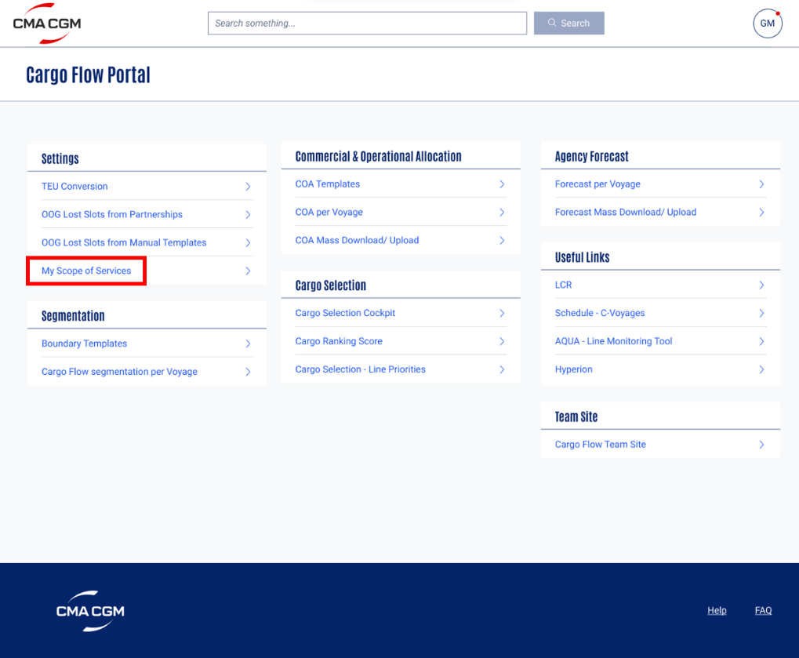

* My Scope of Services screen

* Clicking on the Add button, the commercial GOL field gets displayed

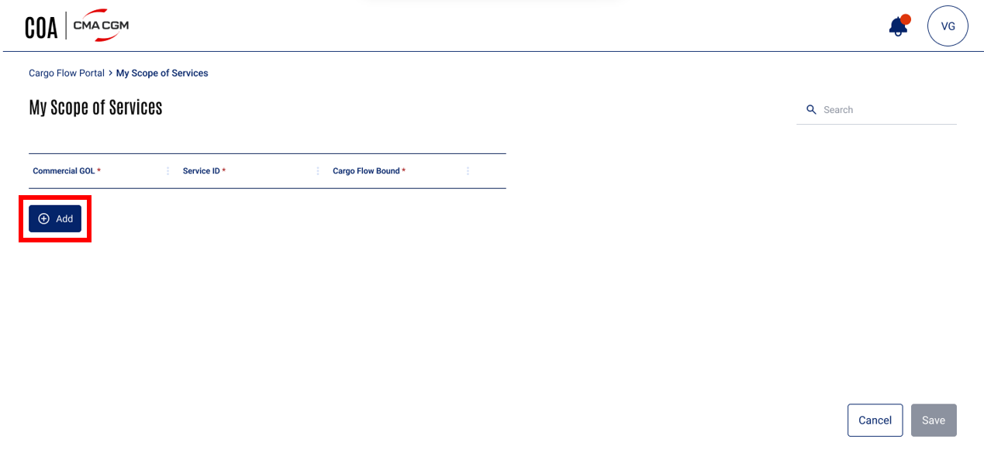

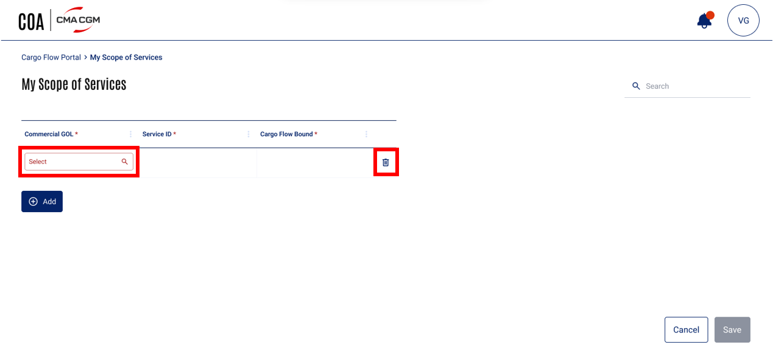

* Entering the Commercial GOL – autosuggestion

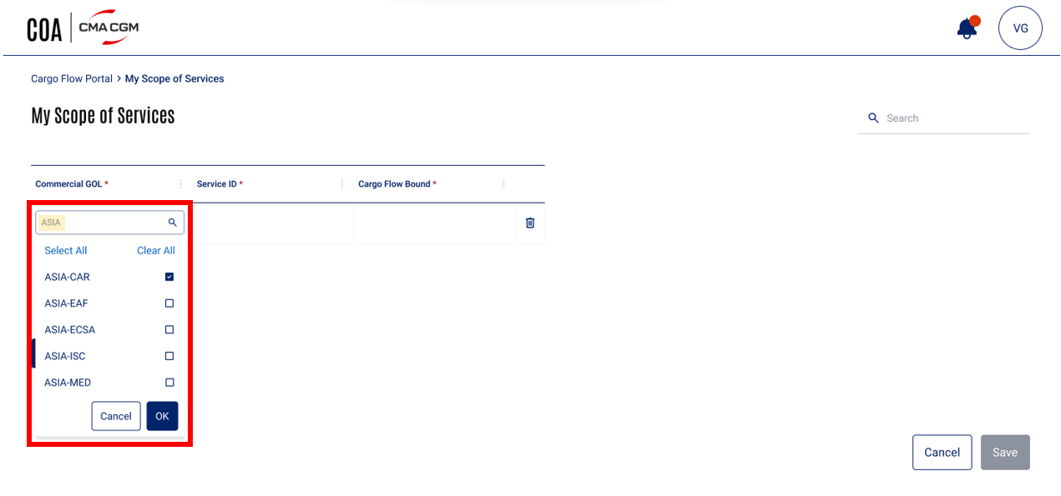

* Entering the Commercial GOL – autosuggestion selection and the empty Service ID field gets displayed

* Entering the Commercial GOL – pop-up search

* Entering the Commercial GOL – pop-up search selection and the empty Service ID field gets displayed

* Entered commercial GOL not defined in master data

* Entering the Service ID- autosuggestion

* Service ID’s pop-up search using autosuggestion

* Service ID not defined in the Schedule or Service ID not limited to the selected commercial GOL

* Selecting the cargo flow bounds from the drop-down

* Duplicate records check and error

* Saving my scope of services

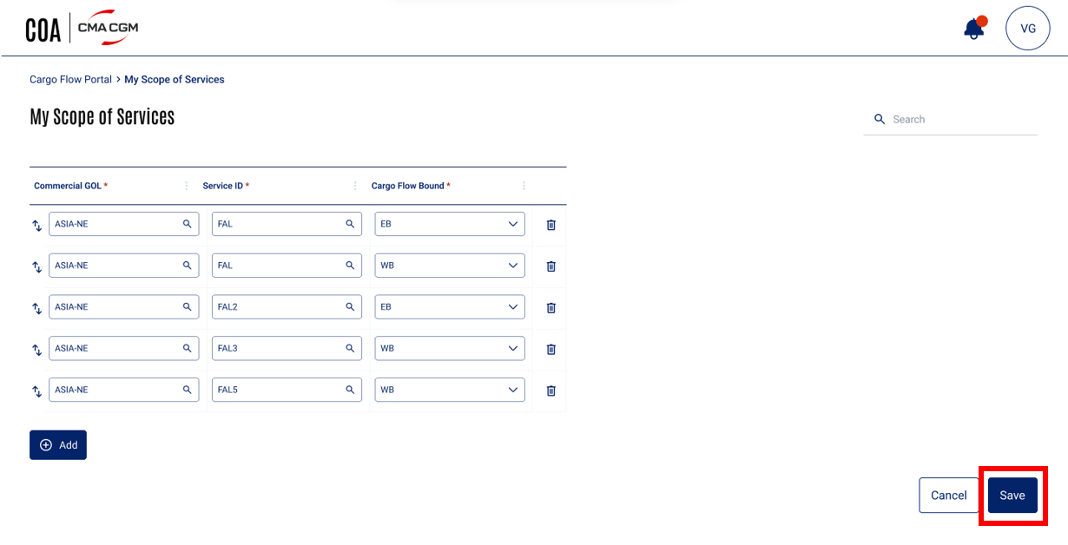

* Confirmation message before saving the scope of services

* Success message once the scope is saved.

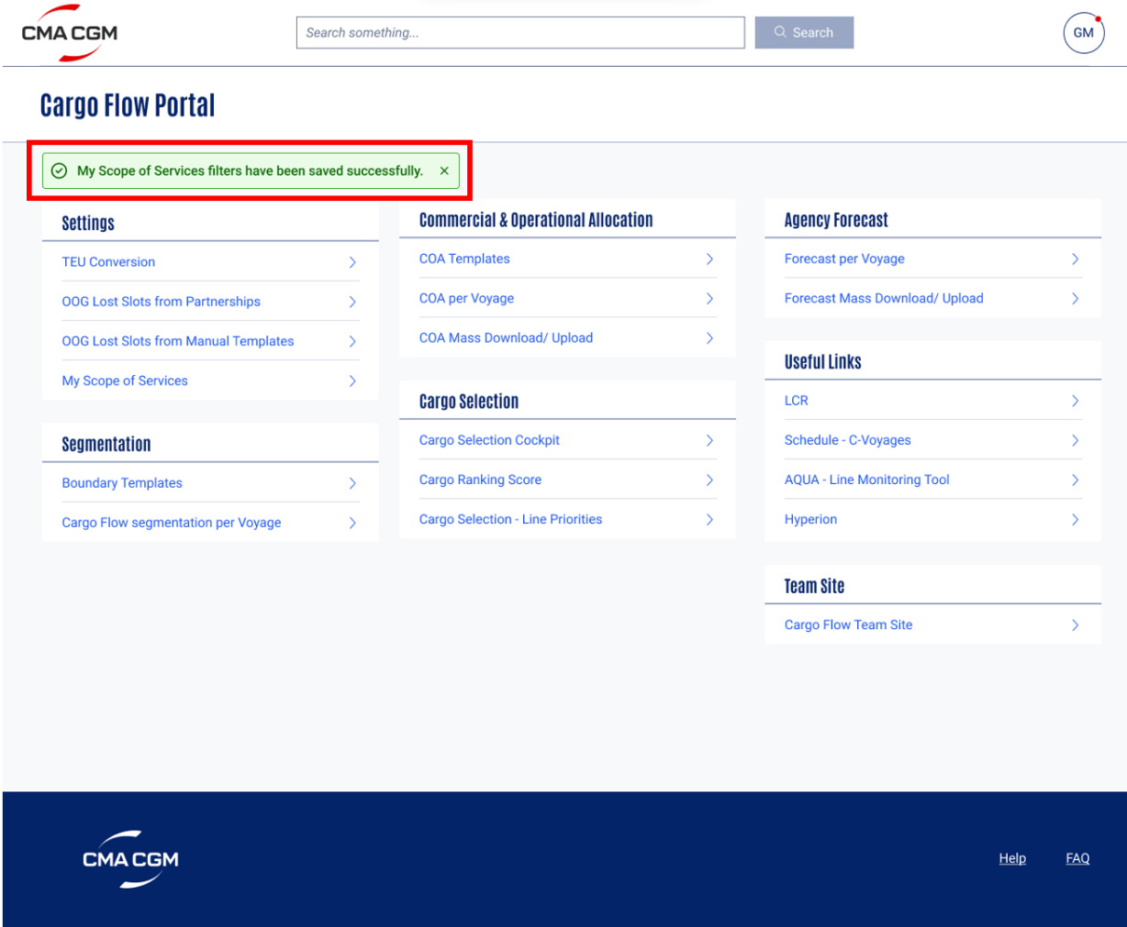

* When user comes on My scope of services to modify/edit scope

* Modified field data will be highlighted in orange

* Confirmation message before saving the modified scope of services

* Success message once the modified scope is saved

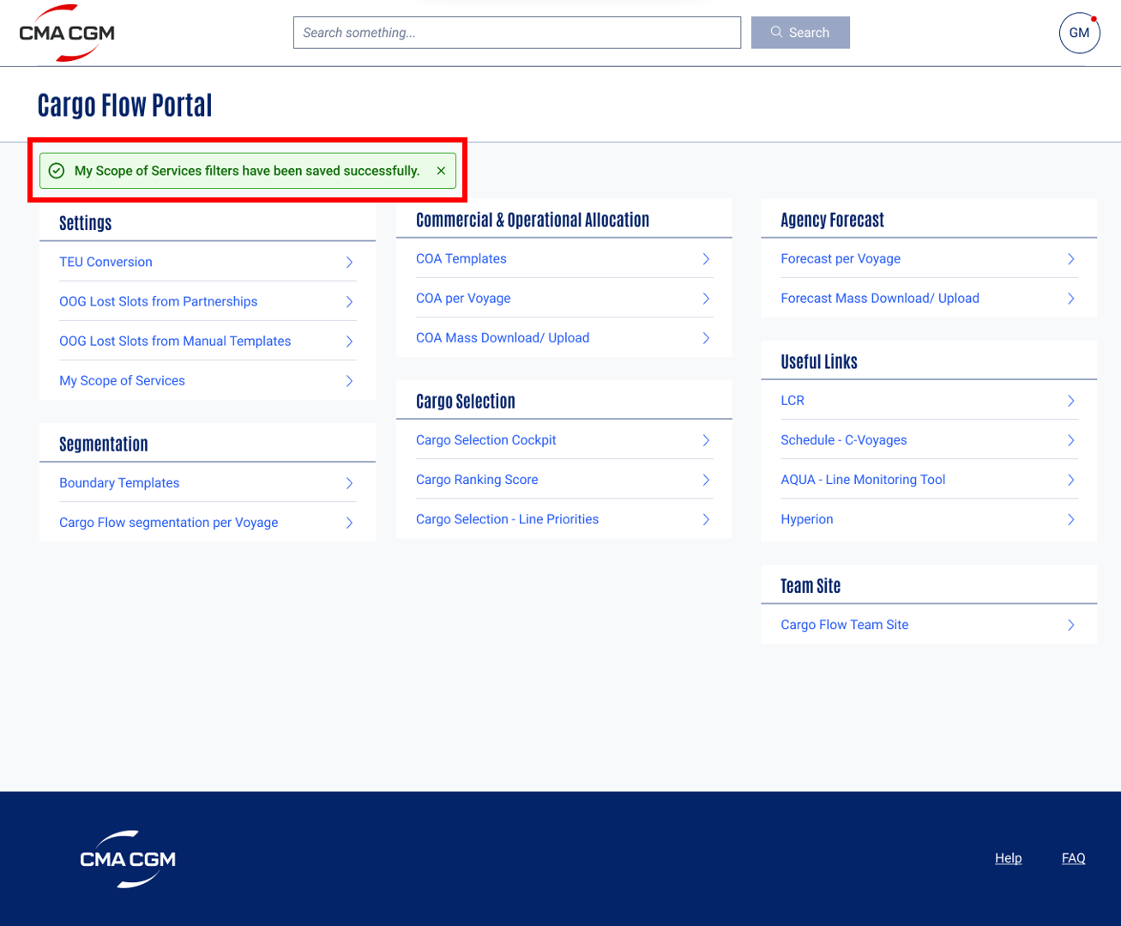

* Cancel setting up of my scope of services when there are unsaved changes

* Cancel setting up of my scope of services when there are unsaved changes – confirmation message

* Cancel setting up of my scope of services when there are unsaved changes - if user clicks on yes button, he is directed to the COA Homepage

### Validation and Rules

Below are the **detail definitions** for **attributes**, button and error message in **My Scope of Services**

|  |  |  |  |  |  |  |  |
| --- | --- | --- | --- | --- | --- | --- | --- |
| **SR** | **Label** | **Description** | **F** | **A** | **D** | **List** | **Rules** |
| 1 | Commercial GOL | Lines are grouped for commercial perspective | FA | M | E |  | BR04 |
| 2 | Service ID | Service ID is associated with the selected Service and will be present in the schedule | FA FN | M | E |  | BR05 |
| 3 | Cargo Flow Bound | Segregation of a voyage into separate blocks that indicate the direction of the vessel sailing | FA | M | E |  | BR06 |
| 4 | Add | Button to add Commercial GOL in the my scope services table | BT |  | E |  | BR03 |
| 5 | Cancel | Button to Cancel the setting up of My scope of services at any time. | BT |  | E |  | BR07 |
| 6 | Save | Button to save the my scope of services | BT |  | D E |  | BR08 |

Legend

|  |  |  |  |  |  |  |  |  |
| --- | --- | --- | --- | --- | --- | --- | --- | --- |
| **Format** | CB | Check Box | **Attribute** | M | Mandatory | **Display** | D | Field disabled |
| FA | Field alpha | O | Optional | E | Field Enabled |
| FN | Field numeric |  |  | R | Read Only |
| LOV | List of Value |  |  | H | Hidden |
| DA | Date |  |  |  |  |
| BT | Button |  |  |  |  |
| DT | Date Time |  |  |  |  |

### Setups and configurations NA

### Processing definition

Following business rules must be implemented:

|  |  |
| --- | --- |
| **ALL-140- My Scope of Services** | |
| **BR01** | **Navigation to the My Scope of Services Screen**   * After Cargo Flow user clicks on the My Scope of Services on the COA Home Page, the user should be directed to my scope of services screen. * The breadcrumb will be Cargo Flow Portal > My Scope of Services. |
| **BR02** | **My Scope of Services Screen Overview**   * The My scope of services screen will have the navigation breadcrumb displayed at the top. * The screen should have label ‘My Scope of Services’. * Attributes such as Commercial GOL, Service ID, Cargo Flow Bound, Add button, Cancel button and Save button are available on the screen. * There will also be a generic search option, it will allow the user to search throughout the page.      * **Mandatory fields-**   + Commercial GOL   + Service ID   + Cargo Flow Bound |
| **BR03** | **Add Button**   * When the add button is clicked, one field under Commercial GOL gets displayed.      * The field is highlighted in red indicating that the field is empty and needs an input value. * Delete icon appears at the end of the row which can delete the entire row. |
| **BR04** | **Commercial GOL**   * Single Commercial GOL or multiple Commercial GOLs can be selected. * User Input - User has 2 options to input the data   **Option 1:** Autosuggestion after 2 characters are typed in the field and the relevant suggestions will appear in alphabetical order    **Option 2**: Search to view all the commercial GOLs from the master data in pop-up window by clicking on the lookup (magnifying glass) icon     * Autosuggestion   + Attributes of the autosuggestion list are     - select all button     - clear all button     - list of 10 most relevant Commercial GOLs autosuggestions from master data     - cancel button     - ok button      * + When Clear All button is clicked, the checkboxes against the selected commercial GOLs from the autosuggestion list will be unticked and the selection will be cleared.   + When Select All button in the autosuggestion list is clicked, all the commercial GOLs in the list will get selected.   + When Cancel button is clicked, the autosuggestion list will close.   + When OK button is clicked, the list will close and the system will create fields for the number of commercial GOLs selected and populate them in sequence of the selection. * Search lookup   + Attributes of the view all commercial GOLs pop-up window are     - search bar     - select all button     - clear button     - a list of all the commercial GOLs in alphabetical order from master data     - checkbox against each commercial GOL to select specific commercial GOL     - number of commercial GOLs selected out of all the commercial GOLs present in the list     - cancel button     - select button      * + When Clear button in the pop-up window is clicked, the checkboxes against the selected commercial GOLs will be unticked and the selection will be cleared.   + When Select All button in the pop-up window is clicked, all the commercial GOLs in the list will get selected.   + When Cancel button is clicked, the pop-window will close.   + When Select button is clicked, the list will close and the system will create fields for the number of commercial GOLs selected and populate them in sequence of the selection. * The list of Commercial GOLs displayed in the autosuggestions and the pop-up window are from the master data and are always displayed alphabetically (sorted A to Z). * If the user manually types the commercial GOL which is not present in master data, the field will be highlighted in red indicating that the input is not valid.      * Once the user gives valid input value in commercial GOL field, it should no longer be highlighted in red. * If single commercial GOL is selected, the empty editable service ID field will be displayed against this single commercial GOL.      * If multiple commercial GOLs are selected, the empty editable service ID fields will be displayed against every commercial GOLs. |
| **BR05** | **Service ID**   * Single or multiple service IDs can be selected. * User Input - User has 2 options to input the data   **Option 1:** Autosuggestion after 2 characters are typed in the field and the relevant suggestions from schedule limited to the selected ‘Commercial GOL’ will appear in alphabetical order    **Option 2**: Search to view all the service IDs limited to the selected ‘Commercial GOL’ from the schedule in pop-up window by clicking on the lookup (magnifying glass) icon     * Autosuggestion   + Attributes of the autosuggestion list are     - select all button     - clear all button     - list of 10 most relevant service IDs autosuggestions from schedule limited to the selected ‘Commercial GOL’     - cancel button     - ok button      * + When Clear All button is clicked, the checkboxes against the selected service IDs from the autosuggestion list will be unticked and the selection will be cleared.   + When Select All button in the autosuggestion list is clicked, all the service IDs in the list will get selected.   + When Cancel button is clicked, the autosuggestion list will close.   + When OK button is clicked following actions will take place simultaneously   + the autosuggestion list will close   + the selected number of service ID fields will be created and populated in sequence of the selection   + no. of populated commercial GOLs field will increase to match the ‘Commercial GOL’ - ‘Service ID’ combinations   + empty editable cargo flow bound fields will be displayed against every ‘Commercial GOL’ - ‘Service ID’ combinations record * Search lookup   + Attributes of the view all service IDs pop-up window are     - search bar     - select all button     - clear button     - a list of service IDs data limited to the selected ‘Commercial GOL’ in alphabetical order from schedule     - checkbox against each service IDs to select specific service ID     - number of service IDs selected out of all the service IDs present in the list     - cancel button     - select button      * + When Clear button in the pop-up window is clicked, the checkboxes against the selected service IDs will be unticked and the selection will be cleared.   + When Select All button in the pop-up window is clicked, all the service IDs in the list will get selected.   + When Cancel button is clicked, the pop-window will close.   + When Select button is clicked, following actions will take place simultaneously   + the pop-up window will close   + the selected number of service ID fields will be created and populated in sequence of the selection   + no. of populated commercial GOLs field will increase to match the ‘Commercial GOL’ - ‘Service ID’ combinations   + empty editable cargo flow bound fields will be displayed against every ‘Commercial GOL’ - ‘Service ID’ combinations record   **Example: When 1 Service ID is selected:**  If user has selected only 1 Commercial GOL let’s say ASIA-NE so there will be only 1 field under Commercial GOL heading but when the user selects FAL under Service ID then 1 fields will be created under Service ID for FAL, Commercial GOL field will still have only 1 ASIA-NE fields and 1 empty editable fields will be displayed against the ‘Commercial GOL’-‘Service ID’ combinations record under Cargo Flow Bound heading.      **Example: When multiple Service IDs are selected:**  If user has selected only 1 Commercial GOL let’s say ASIA-NE so there will be only 1 field under Commercial GOL heading but when the user selects FAL, FAL2 and FAL3 under Service ID then 3 fields will be created under Service ID for FAL, FAL2 and FAL3, Commercial GOL field will now have 3 ASIA-NE fields and 3 empty editable fields will be displayed against every ‘Commercial GOL’-‘Service ID’ combinations record under Cargo Flow Bound heading       * The list of service IDs displayed in the autosuggestions and the pop-up window are from the schedule and limited to the selected commercial GOL. They are always displayed alphabetically (sorted A to Z). * If the user manually types the service ID which is not present in the schedule, the field will be highlighted in red indicating that the input is not valid.      * If the user manually types the service ID which is present in schedule but not limited to the selected commercial GOL, the field will be highlighted in red indicating that the input is not valid.      * Once the user gives valid input value in service ID field, it should no longer be highlighted in red. |
| **BR06** | **Cargo Flow Bound**   * There are only 5 values for this field as follows   + EB   + WB   + NB   + SB   + RT * Single or multiple bounds can be selected.      * **User Input-** User can click the drop-down to view the bounds and select the bounds from the list * Drop-Down   + Attributes of the drop-down list are     - select all button     - clear all button     - list of 5 bounds     - cancel button     - ok button      * + When Clear All button is clicked, the checkboxes against the selected cargo flow bound from the drop-down list will be unticked and the selection will be cleared.   + When Select All button in the drop-down list is clicked, all the cargo flow bounds in the list will get selected.   + When Cancel button is clicked, the drop-down list will close.   + When OK button is clicked following actions will take place simultaneously   + the pop-up window will close   + the selected number of cargo flow bound fields will be created and populated in sequence of the selection   + no. of populated commercial GOLs and Service ID fields will increase to match the ‘Commercial GOL’ - ‘Service ID’ - ‘Cargo Flow Bound’ combinations * If the user selects only one cargo flow bound then only 1 field under the Cargo Flow Bound heading will be populated.   **Example: When 1 Cargo Flow Bound is selected:**  If the user selects 1 Commercial GOL let’s say ASIA-NE and 2 Service IDs let’s say FAL and FAL3 then there will be 2 fields under Commercial GOL and 2 fields under Service ID headings. Now if the user selects only 1 cargo flow bound let’s say EB corresponding to the ‘ASIA-NE’-‘FAL’ records then there will be 2 populated fields under Commercial GOL, 2 populated fields under Service ID and 1 populated field and 1 empty editable field under Cargo Flow Bound headings.         * If the user selects multiple cargo flow bounds then multiple fields under the Cargo Flow Bound heading will be created and populated as per the number of bounds selected. This will also impact the ‘Commercial GOL’-‘Service ID’ combinations record.   **Example: When multiple Cargo Flow Bounds are selected:**  If the user selects 1 Commercial GOL let’s say ASIA-NE and 2 Service IDs let’s say FAL and FAL3 then there will be 2 fields under Commercial GOL, 2 fields under Service ID. Now if the user selects 2 cargo flow bound let’s say EB and WB corresponding to the ‘ASIA-NE’-‘FAL’ records then there will be 3 ASIA-NE fields under Commercial GOL heading, 2 FAL fields and 1 FAL3 field under Service ID heading and 1 EB, 1 WB field and 1 empty editable field under Cargo Flow Bound headings.         * Once the user gives valid input value in schedule bound field, it should no longer be highlighted in red. * Vertical swaps will appear after cargo flow bound field is updated. Every row will have vertical swaps icon to rearrange the entire row.      * **Duplicate records:** * Duplicate check is to ensure that user is not able to save a record that is identical to the one existing. * Duplicate check is based on all the 3 mandatory attributes (‘Commercial GOL’, ‘Service ID’, ‘Cargo Flow Bound’) i.e.; all the attributes should match. * When the user creates duplicate records, immediately the system will pop-up an error message saying, ‘Please ensure there are no identical records before saving.’ and the duplicate records will be highlighted in red. |
| **BR07** | **Cancel** button  While setting up of my scope of services:   * When cancel button is clicked at any time before saving the scope, user confirmation message will pop-up with yes and no options.      * If Yes button is clicked, the user will be directed to the COA Homepage and will lose all the unsaved data. * If No button is clicked, the user will come back to the My scope of services page with all data intact.   While modifying my scope of services:   * When the user comes on my scope of services screen to modify the scope but does not make any changes to the records and clicks on cancel button, the user will be immediately redirected to the COA home page without any further validations. * When the user comes on my scope of services screen, modifies the scope of services records and then clicks on cancel button, user confirmation message will pop-up with yes and no options.      * If Yes button is clicked, the user will be directed to the COA Homepage and will lose all the unsaved data. * If No button is clicked, the user will come back to the my scope of services page with all data intact. |
| **BR08** | **Save** button   * Save button will be inactive and greyed out in case of * mandatory fields not filled * data entry errors * duplicate entries * no changes done to the set existing scope of services (when user opens the My scope of services section to modify the scope) * When the Save button is active and user clicks on it, user confirmation message will pop-up with yes and no options.      * If No button is clicked, the user will come back to my scope of services page with all data intact. * If Yes button is clicked, the my scope of services will be saved and user will be directed to the COA Homepage with a confirmation message “My Scope of Services filters have been saved successfully” on the screen.      * Once the scope is saved, the user will see quick default filters set in the Cargo Flow Portal.   Note: The user can change my scope of services ‘n’ number of times and these quick filters will reflect in user’s Cargo Flow Portal. |
| **BR09** | **Modification of Scope of Services**   * The user should be able to modify the scope of services. * Editing any field, deleting any row or adding a new record from the existing set scope of service is possible. * The modified data in any field should be highlighted in orange.        * Once the fields are modified, the scope of services can be saved again. * The process of saving is explained in the BR08. * Once the modified scope is saved and set, the user will see modified quick default filters set in the Cargo Flow Portal. |
| **BR10** | **Error and Confirmation Messages Placeholder**   * Error messages will be displayed in a rectangular box in red colour, near the notification bell icon (Please refer the Mock-up screens for the position).      * Confirmation message will appear as pop-up with action button. |
| **BR11** | **Clicking on Breadcrumb**   * Breadcrumbs are provided to ease navigation. * If the user clicks on the breadcrumbs when there are some unsaved changes on the My scope of services screen, user is prompted with a confirmation message “You are about to discard all unsaved changes. Do you want to proceed?”.      * If the user clicks Yes in pop-up, the user should be redirected to the page associated to the breadcrumb and the user will lose all the unsaved data from the My scope of services screen. * If user clicks on No, user stays on the same my scope of services screen with all the data intact. * When there are no changes done to the My scope of services screen and the user clicks on the breadcrumbs, the user should be redirected to the page associated to the breadcrumb without any further validations. |
| **BR12** | **Generic Search**   * When the user searches something using the generic search option, the results will be highlighted throughout the page.     Example: If the user types ‘CO’ in the generic search bar option and presses Enter button, all the words with CO alphabets will get highlighted in the entire page like ‘CO’ from the **Co**mmercial GOL and My S**co**pe of Services headings will get highlighted. |
| **BR13** | **NFR**   |  |  |  |  | | --- | --- | --- | --- | | Scenario | Step/transaction | Parameter | NFR | | Refresh the My scope of services screen | Refresh screen | All fields | 1 sec | |

### Functional Test Cases

|  |  |  |  |
| --- | --- | --- | --- |
| **Test case #** | **Rule** | **Functional Test** | **Expected Results** |
| **ALL-140- My Scope of Services** | | | |
| **TC1.0** | BR01 | * When the cargo flow user clicks on ‘My Scope of Services’ on the COA Homepage | * User is redirected to the My Scope of Services screen. |
| **TC2.0** | BR02 | * Check whether all the elements on the My Scope of Services screen matches with the UX/UI Mock-ups. | * Refer section 2.6 UX/UI Designs. |
| **TC3.0** | BR03 | * When the user clicks on the Add button | * An empty editable field is displayed under the Commercial GOL heading and the field will be highlighted in red. Delete icon will appear at the end of the row which will delete the entire row. |
| **TC4.0** | BR04 | * When the user starts typing in the Commercial GOLs empty field | * Autosuggestions will be displayed in alphabetic order from the master data after 2 letters are typed in the field. |
| **TC4.1** | BR04 | * When the user ticks the checkboxes against the Commercial GOLs from the auto-suggested list | * The checkboxes should get ticked indicating that the respective commercial GOLs are selected. |
| **TC4.2** | BR04 | * When the user clicks on the select all option in the commercial GOL autosuggestion list | * All the commercial GOLs present in the list should get selected. |
| **TC4.3** | BR04 | * When the user clicks on the clear option in the commercial GOL autosuggestion list | * The checkboxes against the commercial GOLs selected will be unticked and the selection is cleared. |
| **TC4.4** | BR04 | * When Cancel button is clicked in the autosuggestion list | * The autosuggestion list will close. |
| **TC4.5** | BR04 | * When the user clicks ok button in auto suggestion list | * The autosuggestion list should close. The fields under commercial GOLs will be created and should get populated in the sequence of selection. Concurrently empty editable fields will get created under the Service ID headings against every commercial GOL added. |
| **TC4.6** | BR04 | * When the user types the commercial GOL in the field which is not present in master data | * The cell will get highlighted in red which indicates that the data is invalid. |
| **T4.7** | BR04 | * When the user clicks on the search icon in the commercial GOL field | * The pop-up window opens with the list of all the commercial GOLs present in the master data in alphabetical order. |
| **TC4.8** | BR04 | * When the user clicks on the checkboxes against a commercial GOL(s) from the pop-up window commercial GOL list | * The checkboxes should get ticked indicating that the respective commercial GOLs are selected. |
| **TC4.9** | BR04 | * When the user clicks on the select all option in the pop-up window commercial GOLs list | * All the commercial GOLs present in the list should get selected. |
| **TC4.10** | BR04 | * When the user clicks on the clear option in the pop-up window commercial GOLs | * The checkboxes against the commercial GOLs selected will be unticked and the selection is cleared. |
| **TC4.11** | BR04 | * When the user clicks on the select button in the pop-up window commercial GOLs list | * The pop-up window should close. The fields under commercial GOLs will be created and should get populated in the sequence of selection. Concurrently empty editable fields will get created under the Service ID headings against every commercial GOL added. |
| **TC5.0** | BR05 | * When the user starts typing in the Service ID empty field | * Autosuggestions after 2 letters are typed in the field will be displayed in alphabetic order from the schedule limited to the commercial GOL selected. |
| **TC5.1** | BR05 | * When the user ticks the checkboxes against the Service ID from the auto-suggested list | * The checkboxes should get ticked indicating that the respective Service IDs are selected. |
| **TC5.2** | BR05 | * When the user clicks on the select all option in the Service ID autosuggestion list | * All the Service ID present in the list should get selected. |
| **TC5.3** | BR05 | * When the user clicks on the clear option in the Service ID autosuggestion list | * The checkboxes against the Service ID selected will be unticked and the selection is cleared. |
| **TC5.4** | BR05 | * When Cancel button is clicked in the autosuggestion list | * The autosuggestion list will close. |
| **TC5.5** | BR05 | * When the user clicks ok button in auto suggestion list | * The autosuggestion list should close. The fields under Service ID will be created and should get populated in the sequence of selection. Concurrently, fields under Commercial GOL should appear with populated data for every Service ID field and empty editable fields will get created under the Cargo Flow Bound heading against every Service ID field. (Refer BR05 for details and example). |
| **TC5.6** | BR05 | * When the user types the Service ID in the field which is not present in schedule | * The cell will get highlighted in red which indicates that the data is invalid. |
| **TC5.7** | BR05 | * When the user types the Service ID in the field which is present in schedule but not limited to the commercial GOL selected. | * The cell will get highlighted in red which indicates that the data is invalid. |
| **TC5.8** | BR05 | * When the user clicks on the search icon in the Service ID field | * The pop-up window with the list of all the Service IDs limited to the commercial GOL selected from the schedule in alphabetical order opens. |
| **TC5.9** | BR05 | * When the user clicks on the checkboxes against a Service ID(s) from the pop-up window Service ID list | * The checkboxes should get ticked indicating that the respective Service IDs are selected. |
| **TC5.10** | BR05 | * When the user clicks on the select all option in the pop-up window Service ID list | * All the Service ID present in the list should get selected. |
| **TC5.11** | BR05 | * When the user clicks on the clear option in the pop-up window Service ID | * The checkboxes against the Service ID selected will be unticked and the selection is cleared. |
| **TC5.12** | BR05 | * When the user clicks on the select button in the pop-up window Service ID list | * The pop-up window should close. The fields under Service ID will be created and should get populated in the sequence of selection. Concurrently, fields under Commercial GOL should appear with populated data for every Service ID field and empty editable fields will get created under the Cargo Flow Bound heading against every Service ID field. (Refer BR05 for details and example). |
| **TC6.0** | BR06 | * When the user clicks on the drop-down option in the cargo flow bound field | * He/she should be able to see all the 5 bound options in the list. |
| **TC6.1** | BR06 | * When the user clicks on the checkboxes against cargo flow bound(s) from the drop-down list | * The checkboxes should get ticked indicating that the respective cargo flow bound(s) are selected. |
| **TC6.2** | BR06 | * When the user clicks on the select all option in the drop-down list | * All 5 cargo flow bounds present in the list should get selected. |
| **TC6.3** | BR06 | * When the user clicks on the clear option in the drop-down list | * The checkboxes against the cargo flow bound selected will be unticked and the selection is cleared. |
| **TC6.4** | BR06 | * When the user clicks on the ok button in the drop-down list | * The drop-down list should close. The fields under cargo flow bound will be created and should get populated in the sequence of selection. Concurrently, fields under Commercial GOL and Service ID should appear with populated data for every Cargo Flow Bound field added. (Refer BR05 for details and example). |
| **TC6.5** | BR06 | * When the user clicks on the vertical swap icon before the commercial GOLs to move the entire row | * It should allow the user to rearrange the entire row. |
| **TC6.6** | BR06 | * When the user creates duplicate records | * Error message will pop-up and the fields with duplicate records will be highlighted in red. (Refer BR06 for Error message). |
| **TC7.0** | BR07 | * When the user clicks on the Cancel button and there are some unsaved changes on the screen | * A pop-up window will display a confirmation message with Yes and No option. (Refer BR07). |
| **TC7.1** | BR07 | * When user clicks on Yes button | * The user will be directed to the COA Homepage. |
| **TC7.2** | BR07 | * When user clicks on No button | * The user will come back to the My Scope of Services page with all data intact. |
| **TC7.3** | BR07 | * When the user comes on my scope of services screen to modify the scope but does not make any changes and clicks on cancel button | * The user will be immediately redirected to the COA home page without any further validations. |
| **TC8.0** | BR08 | * When the user clicks on Save button after entering all the valid mandatory details and there are no duplicate records | * A pop-up window will display a confirmation message with Yes and No option. (Refer BR08). |
| **TC8.1** | BR08 | * When user clicks on Yes button | * The user will be directed to the COA Homepage with a success message displayed on the screen. (Refer BR08 for the message). |
| **TC8.2** | BR08 | * When user clicks on No button | * The user will come back to the My Scope of Services page with all data intact. |
| **TC8.3** | BR08 | * When the scope of services is set | * The quick default filters should be applied in the Cargo Flow Portal. |
| **TC9.0** | BR09 | * When the user comes back to My Scope of Services to modify it. | * The save button should be greyed out and disabled as no change is done yet. |
| **TC9.1** | BR09 | * When user make changes to any field | * The modified data in the field should be highlighted in orange and save button becomes active. |
| **TC9.2** | BR09 | * When the user clicks on save. | * Same process as explained in BR08. |
| **TC10.0** | BR10 | * When the user gets an error message | * The save button should be disabled and greyed out. (Refer Mockup for position of the message) |
| **TC10.1** | BR10 | * Test the confirmation message | * Pop-up window will appear with the confirmation message and yes and no options. |
| **TC11.0** | BR11 | * When the user clicks on the breadcrumbs when there are some unsaved changes on the My scope of services screen | * A pop-up window will display a confirmation message with Yes and No option. Refer BR11 for the message. |
| **TC11.1** | BR11 | * When user clicks on Yes button | * The user will be directed to the associated page. |
| **TC11.2** | BR11 | * When user clicks on No button | * The user will stay on the same my scope of services screen with all the data intact. |
| **TC11.3** | BR11 | * When there are no changes done to the My scope of services screen and the user clicks on the breadcrumbs | * The user should be redirected to the page associated to the breadcrumb without any further validations. |
| **TC12.0** | BR12 | * When the user searches something using the generic search option | * The search results should be highlighted throughout the page. |

# - Technical Details (Optional)

Technical solution will be decided by Dev team.

- End of document –